How to Be a Good Father
Edited by mico, Flickety, Ben Rubenstein, Rojo Don Poho and 84 others

Four Parts:
Being Present
Being a Fair Disciplinarian
Being a Good Role Model
Being Understanding

Nobody said being a good father was easy. No matter what age your child is or how many children you have, you have to know that a father's work is never done. To be a good father, you have to be present, be a good disciplinarian and role model, and be sympathetic to your children's needs without being a pushover. If you want to know how to be a good father, just follow these steps.

Part 1 of 4: Being Present
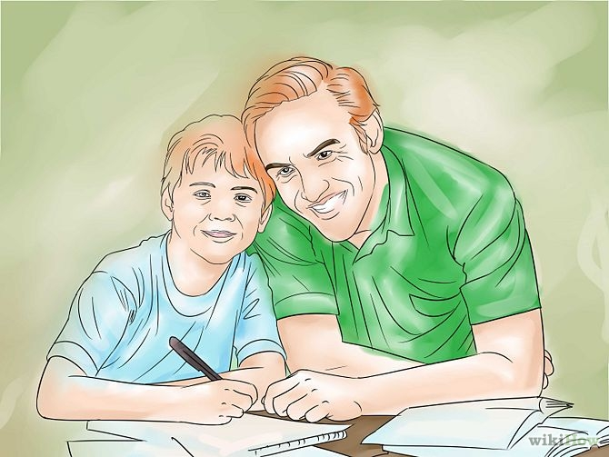
1. Make time for your kids. Your children don't care if you've just had a big promotion at your company or whether or not you own the most expensive house on the block. What they do care about is whether or not you'll be home time for dinner, if you'll take them to the baseball game on Sunday, and if you'll be around for movie night that week. If you want to be a good father, then you have to set aside time every day for your children -- or at least every week -- no matter how busy you are.
• Plug this time into your schedule. Maybe your best nights for your children are Tuesdays, Thursdays, and Sundays. Take the time to put in extra care during those days, and don't let other commitments get in the way.
• If you have more than one child, then you should make time to see each child individually, so your unique relationships can develop.
• If you're so tired that you can't possibly make yourself get up to basketball with your son, do something else with him instead, like watching a basketball game or a basketball-themed movie. It's important that you're there in some capacity.
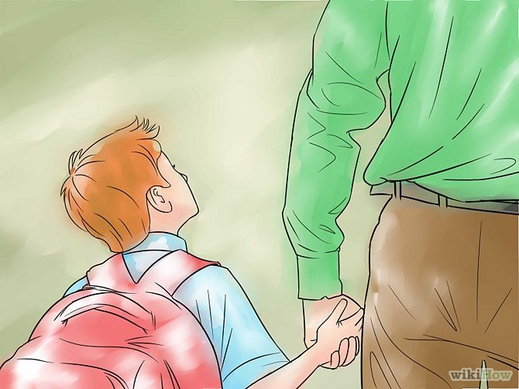
2. Be there for the milestones. Though planning "daddy time" for your kids each week is a great way to strengthen your relationship, you should also try to be there for important milestones in their lives. Arrange your work schedule so that you can be there for your son's first day of school, your daughter's first ballet recital, or your son or daughter's high school graduation.
• Your children will remember these moments for the rest of their lives, and having you be there will mean a lot.
• You may be very busy when one of your kids is about to hit a milestone, but if you miss out, you'll regret it later on.
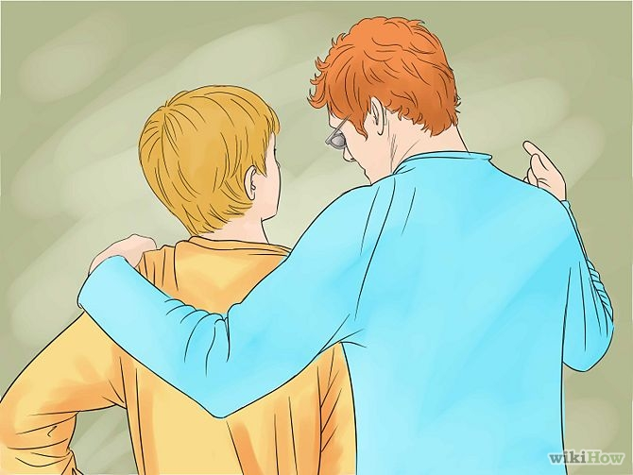
3. Teach your children the important lessons. You should also be present to teach your children how to complete the basic tasks of life. You can help your son use the bathroom, teach your children to brush their teeth properly, help them learn how to ride a bike, and teach them to drive when the time comes. You can also teach your sons how to shave and maintain good hygiene. Your kids will need you to learn the big life lessons as well as the small everyday tasks.[1]
• Split these lessons with your wife. You should both teach your children the important things they need to know to grow up.
• Help your children learn from their mistakes. If they've done something wrong, you should help them see why and talk about how to avoid the behavior in the future instead of simply punishing them and moving on.

4. Develop strong communication. Being present for the important moments in your children's lives is very important, and so is being able to communicate with your children when you're there. You don't always have to do something exciting with your kids for them to enjoy hanging out with you -- you just have to focus on being able to communicate with them, to understand their concerns and struggles.
• Make sure to check in with your kids every day, so that you know what their worried about, what they have coming in that week, and what's on their minds.
• Don't just superficially ask, "How was your day?" without really wanting to know the answer.
• If your children are teenagers or busy college students, then they may not want to discuss the details of their days with you. Just make sure to check in often enough that they know you care without feeling smothered.
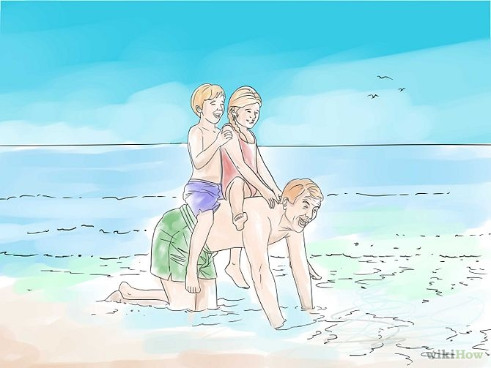
5. Plan trips with your kids. To be a good father, you should take the time to go trips with your kids -- with or without their mother. You can take a yearly fishing trip with your boys, a trip to the beach with your daughter, or even a camping trip that your kids will never forget. Whatever you do, try to make it special, memorable, and something that can be repeated at least once a year so that you've developed a fun daddy-centric routine.
• If the children's mother is present during the trips, take some time to bond solo with your kids when you can.
• Planning these trips a few months in advance will give your kids something fun and different to look forward to.

6. Make time for yourself. Though it's important to be there for your kids, you should try to get some "me time" when you can, whether it's spending Sunday afternoon doing your own thing, or taking half an hour to run every morning or winding down with a good book every night before bed. You should put your kids' interests before your own most of the time, but don't completely neglect yourself, either.
• If you don't make time for yourself, you won't be able to relax, recharge your batteries, and give your kids the time and attention they deserve.
• You can have a special room or chair in the house where your kids know that you should not be disturbed. Help them get used to the idea of "me time" and explain that you're going to be doing your own thing for a little while -- unless they really need you.

Part 2 of 4: Being a Fair Disciplinarian

1. Reward your children appropriately. Being a disciplinarian isn't all about punishing your children when they've made a mistake. It's also about rewarding them when they've done something good so that they're encouraged and want to repeat the behavior. Whether they've gotten straight As, helped a younger sibling with a tough task, or were mature enough to walk away from a fight, you should let them know how proud you are of them, take them out to their favorite restaurant, or just do whatever you can to let them know how much you appreciate their good behavior.
• When your children are younger, rewarding them with affection can go a long way in helping them see how proud you are.
• Though giving your children a treat or a new toy when they've behaved well occasionally can reinforce good behavior, you shouldn't have toys or treats as the only incentive your children have for acting well. They should be motivated because you've taught them to separate right from wrong.
• Don't reward your children for something that is expected of them, like doing chores around the house or cleaning up after themselves. If you do, then they'll feel like they're doing you a favor.

2. Punish your children appropriately. To be a fair disciplinarian, you'll have to punish your children when they've made a mistake. This doesn't mean getting physical or psychologically cruel -- it just means letting your kids know when they've made a mistake and showing that there are consequences for their actions. Once your child is old enough to reason, he should know when he's made a mistake.[2]
• Make sure that you and your wife agree on the punishment for the children. The consequences should be the same, whether Mommy or Daddy witnessed the action. This will help you avoid going into "good cop, bad cop" mode.
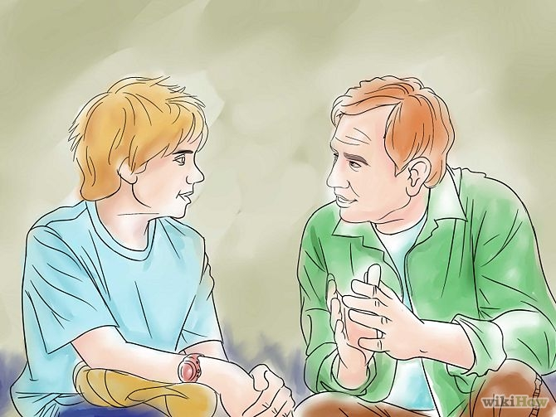
3. Be consistent. Being consistent is just as important as having a system of punishments and rewards. If your child is misbehaving, the consequences should be the same every time, even if it's inconvenient or you're tired or out in public. And if your child does something great, don't forget to make him feel special, no matter how tired or stressed out you are.
• If you don't act consistent, then your children will know that your reactions can be influenced by your moods.

4. Don't yell. Though you may feel enraged by your children's behavior, yelling is not the solution. If you have to yell, try yelling when you're alone, in the shower, or into a pillow. But don't yell at your children, no matter how bad the urge is. You can raise your voice slightly to let them know they've made a mistake, but if you yell or scream, they'll be afraid of you and won't want to communicate.
• Though it may be tough, you shouldn't let your children see you lose control.

5. Don't get violent. No matter how angry you are, you should avoid hitting, hurting, or grabbing your children. This will hurt them physically and emotionally and will make them want to avoid you at all costs. If your children think that you may get violent, they will shut down and won't want to be around you. You should avoid being violent around your children, or around their mother, if you want to gain their respect.[3]

6. Be feared and loved. It's important that your children know that you're a strict disciplinarian and that they can't pull a fast one on you, but it's equally important that they want your love and affection and have an amazing time bonding with you. To be a good father, you need to toe the line between enforcing tough lessons and also making your children feel loved and appreciated.
• If you're too concerned about being feared, then your children may not feel comfortable enough to open up to you.
• If you're too concerned about being loved, then your children may see you as a pushover who won't lay down the law.

Part 3 of 4: Being a Good Role Model

1. Lead by example. If you want to lead by your example, then your motto should be, "Do as I say and as I do," so your children know you're not being hypocritical when you teach them right from wrong. If you want your children to act in a way that meets your expectations, then they should see the positive behavior from you first. Here are some ways that you can lead by example:
• If you don't want your children to smoke or drink excessively, for example, then you shouldn't do these things in front of them -- or at all.
• If you want your children to treat people with kindness and respect, then they have to see you treating people, from the waiter in your local restaurant to a telemarketer, with basic respect.
• If you want your children to not pick fights, then don't pick a fight with their mother right in front of them.

2. Treat the children's mother with respect. If you want to be a good role model, then you have to treat the children's mother with respect. If you're married to her, then you should let them see how much your love her, help her out, and enjoy her company. If you're mean to your own wife, then your children will see that it's okay to be mean to Mom or other people because Dad does it.[4]
• Part of treating the children's mother with respect means sharing childcare and household duties with her.
• Let your children see you praising their mother and giving her the love and affection that she deserves.
• You should not only treat the children's mother with respect, but love her and work on maintaining an loving, fun, and nurturing relationship. If the children's mother is happy, then everyone is happy.
• If you and the children's mother are divorced, then you should never say a bad word about their mother to them, even if you're not on the best terms. Letting them see your less-than-ideal relationship with their mother will make them stressed and confused.
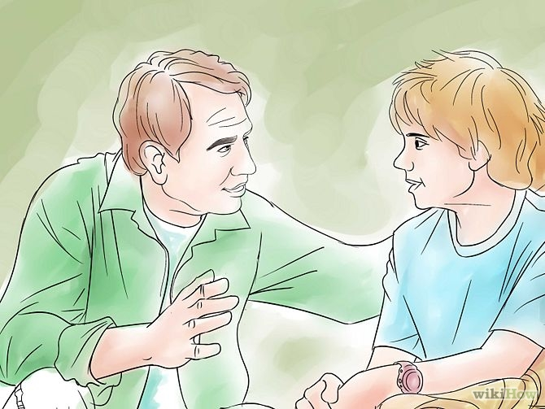
3. Admit your mistakes. You don't have to be perfect to be a good role model. In fact, it's better if you're not perfect, because then your children will see that nobody's perfect and that everybody makes mistakes. If you've made a mistake, like forgetting to pick your child up from school at the right time, or losing your temper, you should apologize and say that you know you've made a mistake.
• If you can swallow your pride in front of your children, then they'll see that it's okay for them to admit when they've done something wrong, too.
• Admitting when you're wrong builds more character than "doing the right thing" every single time.
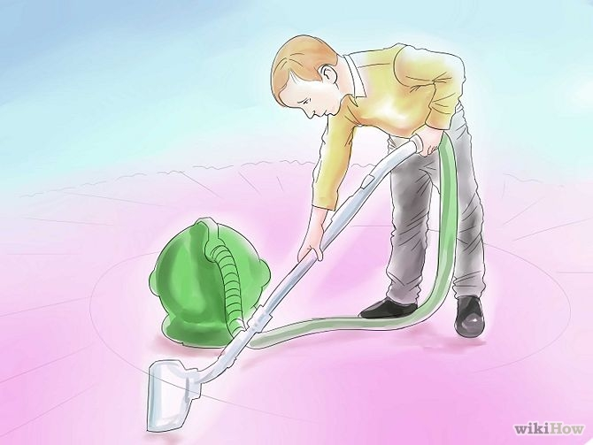
4. Help out around the house. If you want your children to help out around the house, then you should help out around the house, too, no matter how all-consuming your job may be. Let them see you doing the dishes, cleaning the counters, and vacuuming the carpet, and they'll want to help out too. If they think that cleaning up is just "Mom's job," then they'll be much less likely to help out when the time comes.
• Helping out around the house will not only make your wife happy, but it'll help your children see that you and your wife work as a team and that they should join in.
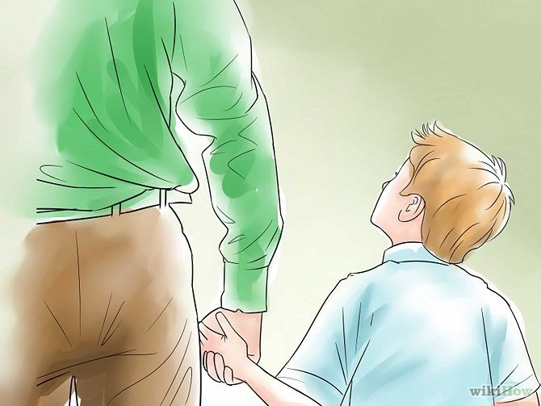
5. Earn your children's respect. Respect is earned, not given, and you should do what you can so that your children respect you as a father. If you're not around a lot, yell at their mother, or are only occasionally in the mood to discipline them, then they won't respect you just because you're their father. You should act in a way that is admirable, honest, and consistent so that your children see that you're a model father and a person worthy of their admiration.
• Your children shouldn't worship you and think you're perfect -- they should see that you're only human and want to do well by them.

6. Shower your children with love and affection. Though you may think being a good role model means being slightly distant but always doing the right thing, it actually means being connected enough to give your children kisses and hugs, and to let them know how much they mean to you. Don't let a day go by without saying "I love you," giving your children physical affection, and letting them know how much they mean to you.[5]
• Your children long for love and affection from you, no matter what age they are.
• Praise your children and let them know that your life wouldn't be the same without them.

Part 4 of 4: Being Understanding

1. Accept that your children aren't you. Though you may have wanted your children to keep running the family business, attend your alma mater, or be a high school soccer star like you were, you have to accept the fact that your children are their own people with their own needs and desires, and that they may not align with yours. You may think that your path is the only way to happiness, but to be a good father, you have to accept that your children may have a different idea of how to run their lives.
• Though you may think that you're doing your best by telling your children what to do or how to live their lives, you're actually hurting their independence by trying to control them.
• It takes time to accept your children's desires. If you don't immediately understand why your son wants to be an artist when you are a doctor, ask for him to explain it to you and take the time to listen and understand.
• If you try to control your children too much, they'll resent you and will stop opening up.
• Let your children make their own decisions by letting them be independent and open-minded. You may want them to play baseball, but sign them up for a variety of activities and let them decide what they like best.

2. Be aware of the changing times. To be a good father, you have to understand that your children aren't growing up in the same environment that you were raised in -- even if you're raising them in the same time. With globalization, the influence of social media, and the changing politics in today's society, it's likely that your children are less sheltered than you are and are more aware of the problems and changes in today's society.[6]
• Therefore, be aware that things like body piercing, premarital sex, and world travel are more common today than they were in your time. Accept that your children are a product of the times and that they may want to explore the world more than you did.
• You may feel like you know exactly how the world should work, but you should let your children express themselves and share their perspectives with you.
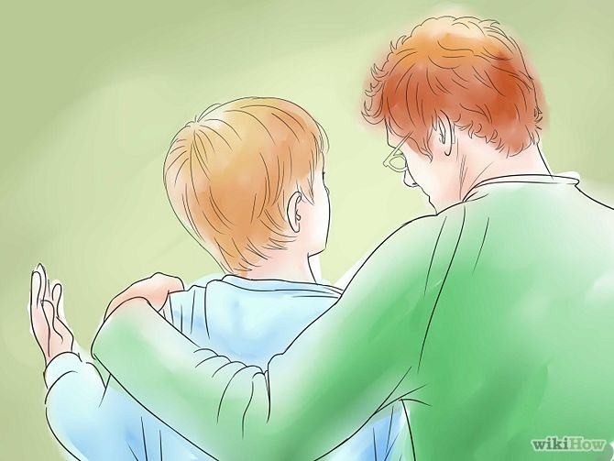
3. Accept your children's mistakes. If you want to be an understanding father, then you have to accept that, like you, your children aren't perfect, and that they're bound to make mistakes. Life is full of mistakes that help your children learn, and you should accept that many lessons are necessary -- whether your son gets into a minor car accident, fails a test because he didn't study, or dates the wrong woman when he should know better.
• If you don't let your children fail once in a while, then they won't learn anything. Though you may want to shelter and protect them, letting them make their own mistakes will help them make more-informed decisions.
• You should still discipline your children appropriately when they make a mistake, but you should also talk about what they did wrong and let them see the error of their ways instead of just yelling at them.
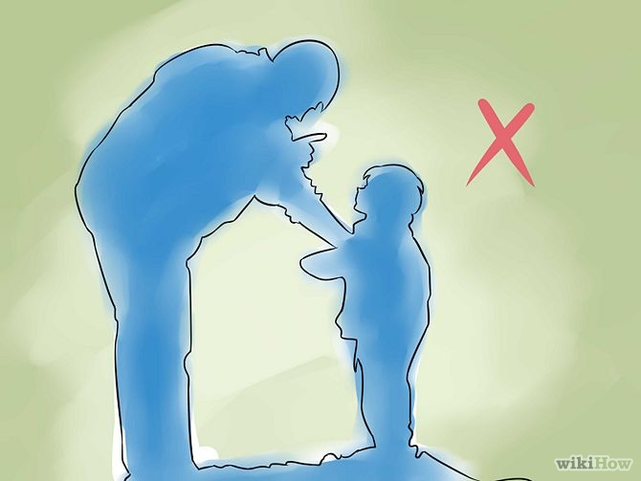
4. Understand if your children are struggling. If you want to be a good father, then you have to be aware of when your children are having a particularly hard time and be attentive to your needs. Maybe your little boy is struggling because you moved to a new town and he doesn't have any friends, or maybe your daughter is going through her first break-up and is emotionally wiped.
• Though you can't completely excuse your children's distant or emotional behavior, you should be aware of what's going through their heads so you can be more understanding and talk to them when they're struggling.
• Just saying, "I know you're having a hard time. Want to talk about it?" will help your children see how much you care.
• Try putting yourself in your child's shoes. If you're frustrated, understanding where your child is coming from will help you understanding his behavior.

5. Don't place unreasonable expectations on your children. A child's life can be filled with pressures, from siblings to kids at school to teachers to coaches. Help your child understand their desires and assess their capabilities and limitations. Help them set achievable goals. Encourage them to meet their full potential but avoid living vicariously through them by expecting them to achieve what you had achieved or hoped to have achieved.

6. Realize that a father's job is never done. Do not assume that once your children turn 21, or they have a college degree, that your work raising them is done. Although it is important to encourage your children to become financially and emotionally independent, it is also important to let them know that you care and are always there for them and that they are valued.

Sources and Citations
1. http://goodmenproject.com/fathers-day/100-ways-to-be-a-good-father/
2. http://www.askmen.com/money/body_and_mind_60/96_better_living.html
3. http://www.parents.com/parenting/dads/101/ways-to-be-a-great-dad/?page=5
4. http://www.artofmanliness.com/2008/08/03/18-tips-for-being-a-great-dad/
5. http://www.parents.com/parenting/dads/101/ways-to-be-a-great-dad/?page=4
6. http://www.askmen.com/money/body_and_mind_60/96_better_living.html

